Hervey Bay Hockey Association
Come & Try
Social Summer Mixed Hockey Competition 2020
6 Week Competition

Mixed Hockey Teams

Modified Rules Involving All Players

Competition Runs Tuesday Evenings

Commencing 27th October – 1st December

Cost Per Player $30 no other fees

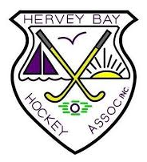

Come along and enjoy the HBHA Social Summer Mixed Hockey Competition as we conclude our modified 2020 Season. The Committee at HBHA would like to thank you for your continued support this year. If you have any questions, please contact Phil Taylor on 0434641457. We look forward to seeing you again in 2021.

